**Assignment 1**

Register with RosettaHub, set up AWS, install linux and compile John the Ripper. Running a benchmarking script.

Steps for setting up AWS and running benchmarking scripts

a. Creating an instance

1. Open RH and create a linux instance -> in this case search for Ubuntu 18.04 image from images and click on launch
2. It will prompt you to select spot instance type and other settings, leave them as is
3. Once created the image appears in the top under “Sessions”
4. Right click on the image and click check connectivity info
5. Download the private keys .pem and .ppk and rename them to something memorable and easier
6. Download WinSCP and putty (for windows os)

b. Setting up WinSCP and putty

1. Open WinSCP and log in by entering the host name, port number and ppk downloaded from step 5 above.

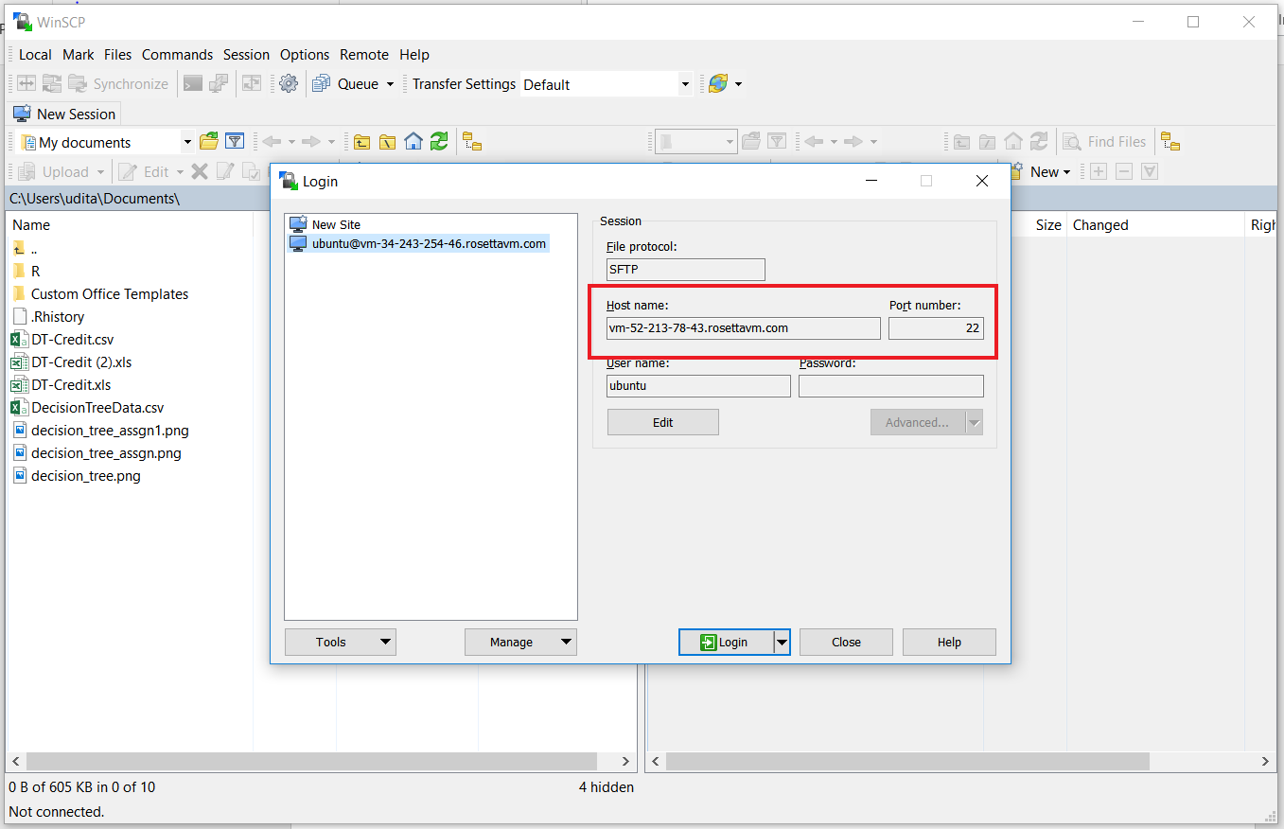

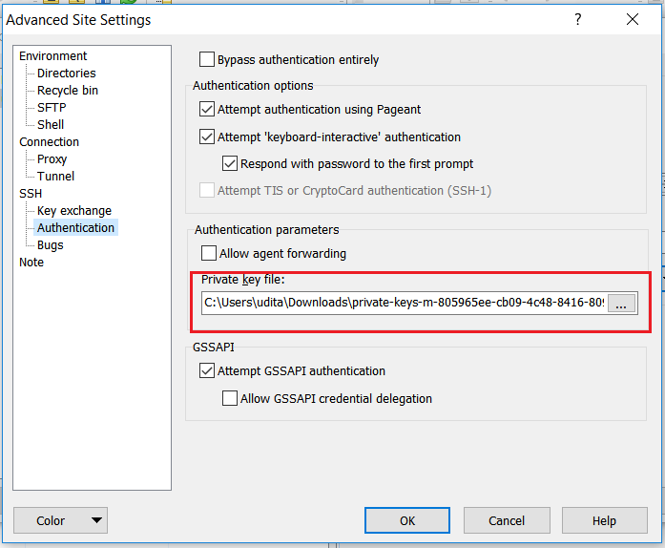

1. Once this is done clone the John the Ripper git repo into the home directory i.e. ubuntu/home/code/JohnTheRipper
2. Open Putty.exe (in my case I could not open it directly from my WinSCP for some reason). Connect to putty by entering the port number, name and keys as follows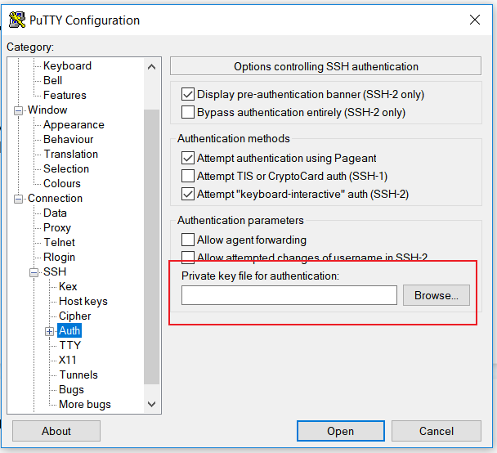

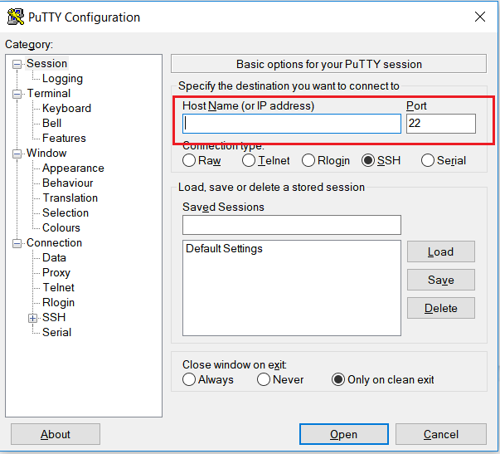

1. Open putty and login as : ubuntu

c. Installing JohnTheRipper and running the benchmarking script

1. Copy the benchmarking scripts to the run folder
2. cd into the src folder (ex. ubuntu@ip-172-30-2-21:~/code/JohnTheRipper/run$ cd /home/ubuntu/code/JohnTheRipper 🡪 path of benchmark script)
3. Run the following scripts in order
4. mkdir -p ~/src
5. sudo apt-get install build-essential libssl-dev git
6. cd ~/src/john/src
7. **sudo chmod +x ./configure** 🡪 had to set permissions for configure command
8. ./configure && make -s clean && make -sj4
9. $ ../run/john --test=0 🡪 test the build and run step vii if successful
10. $ ../run/john –test 🡪 runs the benchmarking script

Ex.

ubuntu@ip-172-30-2-21:~/code/JohnTheRipper$ ./as2-bench.sh

Will run 2 OpenMP threads

./as2-bench.sh: line 121: ./as2-validator.sh

Your output is in as2-output.bench

1. Uploaded the .bench file successfully to submitty
2. Create an image of the machine and stop the instance

**My takeaways/challenges**

1. Learned how to set up AWS account and create, run an instance on RosettaHub
2. Learned to install JohnTheRipper(Jtr) and basics of linux commands, how to SSH into image, getting the directory right. I had to run the entire script again as I cloned Jtr in the incorrect folder the first time around.
3. I followed the scripts mentioned in the assignment github repo but still faced an issue with .configure command. It gave me a *“bash: ./configure: Permission denied”.* For this I modified the permissions using *“sudo chmod +x ./configure”*